TASK 1 :
. Blue Solid Lines represent a physical Ethernet cable connection.
. Dashed Lines represent a wireless Wi-Fi connection.

graph TD
%% Define external source
Internet((THE INTERNET))

%% Define main hardware devices
Modem[MODEM\nCommunicates with ISP]
Router[ROUTER\nAssigns IP Addresses\nManages Traffic]
Switch[NETWORK SWITCH\nConnects wired devices]
AP[WIRELESS ACCESS POINT (AP)\nBroadcasts Wi-Fi signal]

%% Define client devices
Desktop[Desktop PC\n(Wired)]
SmartTV[Smart TV\n(Wired)]
Laptop[Laptop\n(Wireless)]
Phone[Smartphone\n(Wireless)]

%% Connect the devices
Internet ---|Coaxial/Fiber| Modem
Modem ---|Ethernet| Router
Router ---|Ethernet| Switch
Router -.->|Wi-Fi| Laptop
Router -.->|Wi-Fi| Phone
Switch ---|Ethernet| AP
Switch ---|Ethernet| Desktop
Switch ---|Ethernet| SmartTV

%% Connect AP to wireless devices
AP -.->|Wi-Fi| Laptop
AP -.->|Wi-Fi| Phone

%% Styling
style Internet fill:#f9f,stroke:#333,stroke-width:2px
style Modem fill:#ccf,stroke:#333,stroke-width:2px
style Router fill:#ff9,stroke:#333,stroke-width:2px
style Switch fill:#dfd,stroke:#333,stroke-width:2px
style AP fill:#fdd,stroke:#333,stroke-width:2px––

This shows a robust setup. The Internet comes into the Modem. The Router connects to the modem and manages all traffic. To expand the number of wired ports, a Switch is connected to the router. A separate Access Point is also connected to the switch to provide a second, strong Wi-Fi signal in another part of the house. This lets devices like your laptop and phone connect to Wi-Fi seamlessly, while your PC and TV have a reliable wired connection.
TASK 2:
Device | Main Function | Real-Life Example of Use
Modem | Converts a signal from an Internet Service Provider (ISP) into a digital signal that a computer can understand. It is your "bridge" to the internet. | Located next to where your internet cable enters your home; provided by your ISP (like Comcast, Spectrum, or AT&T).
Router | Connects multiple devices together to form a local network (LAN) and manages the flow of data between that network and the internet. It assigns a unique local IP address to every device. | Positioned centrally in a home to share a single internet connection with laptops, phones, and smart TVs via Wi-Fi.
Switch | Connects devices within a network using Ethernet cables, allowing them to communicate with each other efficiently by sending data directly to the correct device. | Used in a home office or entertainment center to connect a gaming console, desktop PC, and smart TV to the network using a physical cable.
Wireless Access Point (AP) | Extends the wireless coverage of an existing network by connecting to a router (via a cable) and broadcasting its own Wi-Fi signal. | A small disk-shaped device mounted on the ceiling of a large office building or a school hallway to provide seamless Wi-Fi coverage everywhere.
Network Cable | A physical medium used to connect networking devices to each other. The most common type is an Ethernet cable. | The blue or yellow cord you plug into the back of your laptop to get a faster, more reliable internet connection than Wi-Fi.

TASK 3:
Ethernet Cable (Cat5e/Cat6):
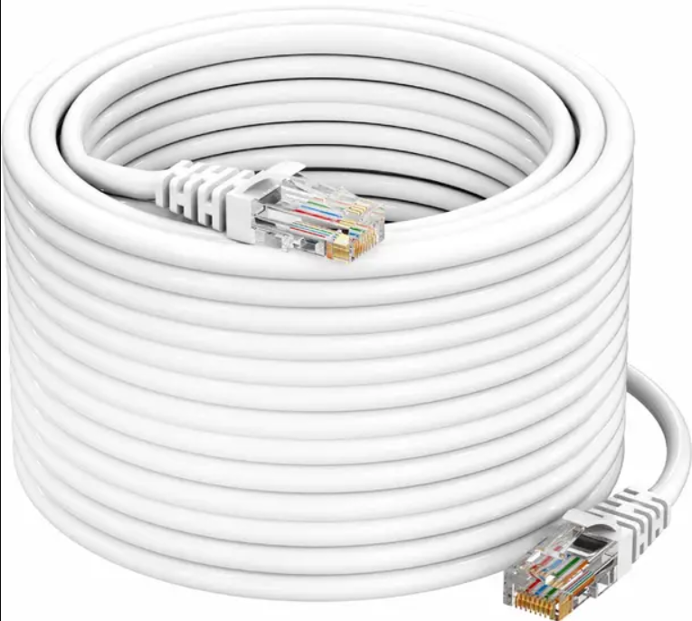
USE : Connects local network devices, like linking a desktop computer to a router or switch in a home or office

Coaxial Cable : Used by cable companies to deliver high-speed internet and TV signals from the street to the modem in your home.
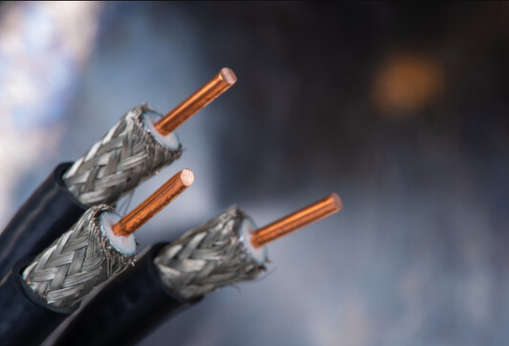
Fiber Optic Cable : Transmits data as light pulses, making it perfect for ultra-high-speed internet backbones that span cities and connect continents.
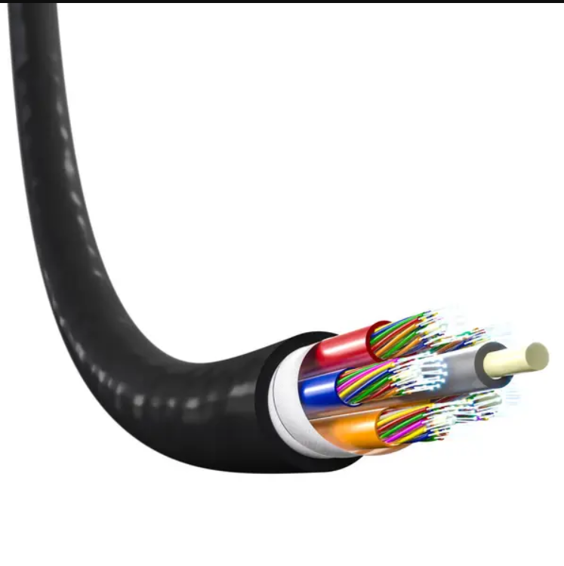
TASK 4 :

Feature | ROUTER | SWITCH
Main Use | To connect and route data between different networks, like your home network and the internet. | To connect devices within a single network, like multiple computers in one room.
Typical Location | At the "edge" of a network, connected directly to a modem. | Within a network, often connected to a router to add more wired ports.
How Data is Handled | Inspects each packet of data to determine its destination IP address and sends it along the best path to that address. | Inspects each data frame to find its destination MAC address and sends it directly to the port that device is connected to.
Connectivity | Typically handles both wired (Ethernet) and wireless (Wi-Fi) connections. | Primarily used for wired (Ethernet) connections (though some managed switches exist).
Internet Access | Crucial for sharing a single internet connection with multiple devices. | Cannot provide internet access on its own; it requires a router.

